Unit Plan
Title: | Selfies (A media literacy unit) | Teacher: | Stephanie Van Dewark
School: | McCoy High School | Grade: | 10-1
Dates: | March 11 – April 2 (Three and a half Weeks)

Overview:
This three week unit is a study in media and visual representation. We will be using the theme of selfies as an approach to student learning. The phenomenon is one that students are familiar with in their day to day interactions with technology, but I want my students to realize that corporations, companies, directors, and authors are using similar strategies to represent themselves, their product, and their characters. Therefore we will be examining the essential question “how do individuals create and represent themselves in a public space?” We will be using a variety of advertisements, commercials, photography, and news stories. Students will learn to identify the intended audience, purpose, and biases of these sources. Additionally, they will identify the various techniques used in representation, such as camera angle, distance, lighting, color, perspective, etc.
Content will be presented through facilitated discussion in large and small groups. Students will consult their textbook and other teacher provided notes and resources to critically examine media texts. Throughout the unit they will complete several reflections, gathering their own examples of effective media, and finally, creating their own. Thus they will engage in reading, writing, viewing, and representing strategies.

Rational:
When it comes to media texts, students are both consumers and creators. While they are viewing films, videos, gifs, headlines and advertisements, they are also creating vines, tweets, blogs, posts, and much more. In the Selfies unit, they will continue to work on their critical thinking skills as they evaluate different visual texts, in addition to reflecting on their own public presence on, and offline. Their reflections, media presentations, and final project allow students to recognize effective media elements and the comment on their representational effect. Thus students will address general learning outcomes two, three, and five, as they respond to different forms, manage information, and create effective texts.
Essential Question:
How do individuals create and represent themselves in a public space?

Alignment with Five Areas of ELA Curriculum:
 | Learning Activities
Reading | “Identities” by Valgardson  Articles in “Retouching Reality Lesson”
Writing | Daily written reflections  Media Critical Response  Written Response to the Project  Written peer evaluations on projects  Articles in “Retouching Reality Lesson”
Viewing | Meaningful Text Presentations  Campaign Collection  Project Viewing  “Retouching Reality” Lesson
Listening | Examination of how sound effects, music, and narration can affect commecials (see “MCR lesson 1,” and “Gender Expectation” lesson)

Objectives:
2.2.1 Understand and appreciate textual forms, elements and techniques to relate form, structure and medium to purpose, audience and content. | b) describe audience factors that may have influenced a text creator’s choice of form and medium [for example, age, gender and culture of the audience]  c) describe a variety of organizational patterns and structural features that contribute to purpose and content  d) describe the characteristics of various common communications media [such as the use of headlines in newspapers, and menus and tabs in Internet Web pages]
2.2.2 Relate elements, devices and techniques to created effects | f. recognize the use of elements of effective oral, visual and multimedia presentations [such as movement, gesture, use of space, shape and colour]; and describe their effects  g. identify persuasive techniques used in a variety of print and nonprint texts [such as appealing to emotion and citing experts]
2.3.1 Respond to a variety of print and non-print texts | b) respond personally and analytically to ideas developed in works of literature and other texts; and analyze the ways in which ideas are reflected in personal and cultural opinions, values, beliefs and perspectives
2.3.2 Evaluate the verisimilitude, appropriateness and significance of print and non print texts | a. identify criteria to evaluate the effectiveness of texts, monitor the effectiveness of the criteria, and modify the criteria as needed [for example, use criteria to assess the adequacy, relevance and effectiveness of content and to assess the text creator’s voice and style]  b. assess the appropriateness of own and others’ understandings and interpretations of works of literature and other texts, by referring to the works and texts for supporting or contradictory evidence
3.2.2 Follow a plan of inquiry to evaluate sources and assess information | a. reflect on and describe strategies to evaluate information sources for credibility and bias and for quality; and select, monitor and modify strategies as needed to evaluate sources and detect bias  b. assess information sources for appropriateness to purpose, audience and presentation form  c. assess the accuracy, completeness, currency and relevance of information selected from sources; and assess the appropriateness of the information for purpose  d. identify and describe possible biases of sources [such as possible biases of text creators
4.1.1 Develop and present a variety of print and non-print texts to assess text creation context | b) identify purpose and target audience for text creation and select strategies to accomplish purpose and engage audience  c) Describe and address audience factors that affect text creation
4.2.1 Improve thoughtfulness, effectiveness and correctness of communication to enhance thought and understanding and support detail | b) review the accuracy, specificity and precision of details, events, images, facts or other data intended to support a controlling idea or to develop a unifying effect; and add to details, events, images, facts or other data as needed to provide sufficient support or development
4.2.2 Improve thoughtfulness, effectiveness and correctness of communication to consider and address matters of choice | d) describe the effects of own use of stylistic techniques and rhetorical devices [for example, describe the clarity achieved by arranging words and phrases in lists; describe the emphasis created by using repetition, balance or parallel structure; and describe the audience effects achieved by using visual elements and sounds in presentations and multimedia texts]
*Daily learning objectives are included in the weekly plans and lesson plans.

Resources:
*Daily videos and internet sources are included in the weekly plans and lesson plans

Textbook:
Crane, M., Fullerton, B., Joseph, A., & Prentice Hall Canada. (2000). Prentice hall literature: Sightlines 10. Toronto: Prentice Hall Canada.
Dawe, R. T., Duncan, B., Mathieu, W. L., Cutting, R., Pearson, R., & Prentice Hall Ginn Canada. (1999). Prentice hall language: Resource Lines 9/10. Scarborough, Ont: Prentice Hall Ginn Canada.

Lesson Reference:
Alexander, S. (2014). Processing the News: Retouching in Photojournalism. American Photo. Retrieved March 12, 2014 from http://www.americanphotomag.com/processing-news-retouching-photojournalism?image=2

Carpenter, D., & Smart, B. (1989). Media images & issues. Don Mills, ON: Addison-Wesley Publishers.

Common Sense Education. (2015). Retouching Reality (9-12). Retrieved March 10, 2014 from https://www.commonsensemedia.org/educators/lesson/retouching-reality-9-12
Galang, F. (2014). MADD Canada Project Details [Blog]. Retrieved February 25, 2015 from http://www.nomadcreatives.com/blog/2014/03/04/post-2/
Milner, J. O., & Milner, L. F. M. (2003). Bridging English. Upper Saddle River, N.J: Merrill Prentice Hall.
Online Videos and Images:
LEGO Commercial: Inspire Imagination and Keep Building: https://www.youtube.com/watch?v=BfhV3Q4LJPM
LEGO Friends Heartlake City Pool TV Commercial: https://www.youtube.com/watch?v=j_9x2pi-noo
LEGO Alien Conquest Ad: https://www.youtube.com/watch?v=o0pWMhAodfE&list=PLC74BA4B0EF445F8C&index=8
Amnesty International Ad Campaign “It’s not happening here. But it is happening now.”: http://simplepimple.com/2013/10/its-not-happening-here-but-it-is-happening-now-brilliant-ad-campaign-by-amnesty-international-10-pictures/

Unit Assessment Plan

Stage 1 – Desired Results
Established Goals:
2: Comprehend literature and other texts in oral print, visual and multimedia forms, and respond personally, critically, and creative.
2.2 Understand and appreciate textual forms, elements and techniques.
2.3 Respond to a variety of print and non-print texts
3: Manage ideas and information.
3.2 Follow a plan of inquiry.
4: Create oral, print, visual and multimedia texts and enhance the clarity and artistry of communication.
4.1: Develop and present a variety of print and nonprint texts.
4.2 Improve thoughtfulness, effectiveness and correctness of communication.
Understandings:  Students will understand…  The impact of advertising, media in their lives.  The techniques and elements used to appeal to an audience.  Gain an understanding of their social media presence. | Essential Questions:  How do individuals create and represent themselves in a public space?
Students will know…  2.2.2 Relate elements, devices, and techniques to created effects (in the sense that they will know the difference between the different techniques).  3.2.2 Evaluate sources, and assess information. | Students will be able to do…  2.2.1 Relate form, structure, and medium to purpose, audience, and content  2.2.2 Relate elements, devices and techniques to created effects.  2.3.1 Connect self, text, culture and milieu  4.1.1 Assess text creation context.  4.1.2 Consider and address form, structure and medium.  4.2.1 Enhance though and understanding and support and detail.

Learning Outcomes | Assessments
 | Title | Meaningful Text Presentation | Selfie Reflection | Media Critical Response | Final Media Project | Campaign Collection
 | Type (Formative/Summative) | Formative | Summative | Formative and Summative | Summative | Formative
 | Weighting | 0% | 15% | 40% | 45% | 0%
2.2.1 Understand and appreciate textual forms, elements and techniques to relate form, structure and medium to purpose, audience and content.
2.2.2 Understand and appreciate textual forms, elements and techniques to relate to relate elements, devices and techniques to created effects.
2.3.1 Respond to a variety of print and non-print texts to connect self, text, culture and milieu.
4.1.1 Develop and present a variety of print and nonprint texts to assess text creation context.
4.1.2 Develop and present a variety of print and nonprint texts to consider and address form, structure and medium.
4.2.2 Improve thoughtfulness, effectiveness and correctness of communication and enhance though and understanding and support and detail.
3.2.2 Follow a plan of inquiry to evaluate sources and assess information

Assessment Tool Overview
Assessment Tool | Brief Description | Assessment FOR Learning | Assessment AS Learning | Assessment OF Learning
Meaningful Text Presentation | In the first 10 minutes of class groups of 2-3 students will present a few texts to the class that they find memorable and effective examples of public media. In the presentation students must state why they chose it, the purpose of the text and a few elements that the creator chooses to achieve that purpose. Though all students must complete the assignment, it will not be summatively assessed.
Selfie Reflection | On the first day of the unit students will submit a selfie of themselves which will be displayed in the class. On the last day of the unit they will submit a revised selfie with a rational explaining how they adjusted the picture to better represent themselves. Final submission will be assessed with the same rubric used for the media critiques. The rubric will be shared with the class prior to final submission along with an example.
Media Critiques | The students will do a series of three media critiques (no more than a page length written response) on a weekly basis. Each critique will be reviewed and receive descriptive formative feedback. At the end of the unit they will choose one critique review to revise (if they wish) and submit for grading. Submissions will be assessed with a rubric that students will have access to in their unit overview.
Campaign Collection and Assessment | In small groups students will use web resources to gather 5 effective example of advertising campaigns. They will then rate these images from best to worse and assemble them in a word document. Each individual will assess their top three images using the visual representation rubrics provided. They will also evaluate the collection of another group with the same rubric and compare their findings. I will briefly review the students’ collection to ensure students are identifying effective techniques, but the project will not be summatively assessed.
Final Media Project | Students will create a visual media piece for a social awareness campaign. Students will choose the topic from a brainstormed list of social issues assembled prior. They may choose the form from several provided examples, but choices will range from written news articles, to posters, to video commercials. The project will assess the students’ ability to create effective media, consider their audience, and communicate a clear purpose. Before handing in for final evaluation, students will participate in a series of peer and self-evaluations for their projects and for the work and effort of their group members. These will be in the form of checklists and comment cards. Projects will be assessed using a rubric that aligns with the format they have chosen (provided to students in their assignment overview).

Classroom Displays:
Class Selfies:
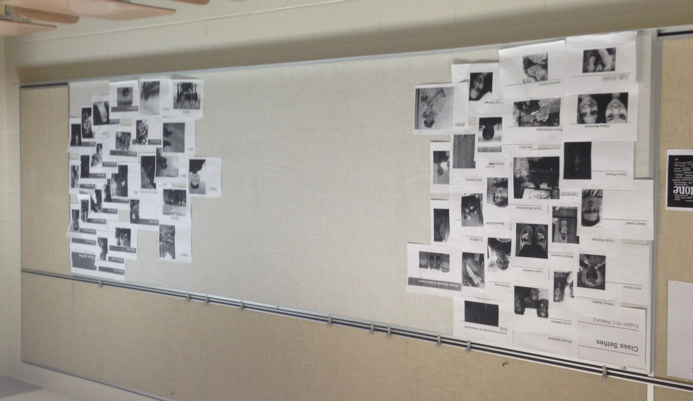
Final Projects:
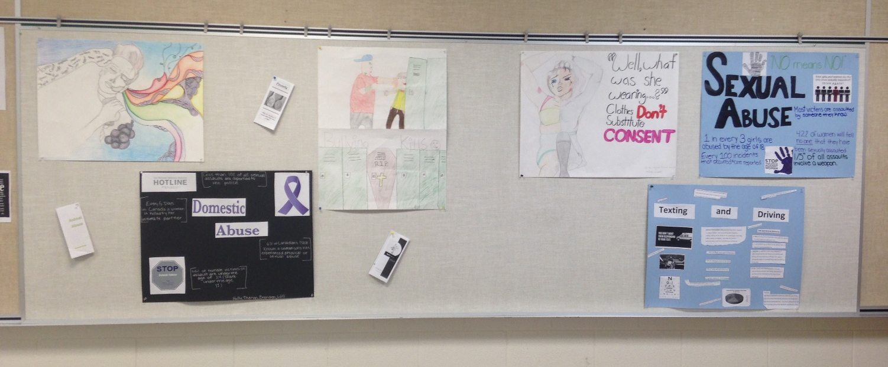
Differentiated instructional considerations:
Once I gain a greater knowledge of my students, I will be able to alter my lessons for their needs. At the moment, I have planned my assessments to gather both written and visual products of their learning to accommodate the potential writing limitations of the students (plus, let’s face it, even I get tired of writing for the teacher). Daily activities will be a combination of both individual and group work for the collaborative and individual learner alike. Choice in the final performance task, in addition to choice in the meaningful texts presentations, will allow students to pursue their own interests and hopefully encourage their full engagement.
Connections to other Units:
Throughout our discussion of visuals and representations, we will also discuss how authors use similar methods to construct their own thoughts, ideas, and characters through written and spoken word. Thus we will connect to similar analytical elements from their novel study and develop skills that can transfer to future units. Considerations in regards to audience, purpose, theme and modality can all be extended to other texts as they move through the year.
Connections to ICT Curriculum:
English Curriculum SLOs | ICT Curriculum SLOs
2.2.1  10-1c describe a variety of organizational patterns and structural features that contribute to purpose and content  10-1d describe the characteristics of various common communications media [such as the use of headlines in newspapers, and menus and tabs in Internet Web pages]  10-1a identify a variety of text forms, including communications forms and literary forms [for example, letters, memoranda, poems, narratives and dramatizations]; and describe the relationships of form to purpose and content | P1 - 4.3  Apply general principles of graphic layout and design to a document in process.  C1 – 4.4  communicate in a persuasive and engaging manner, through appropriate forms, such as speeches, letters, reports and multimedia presentations, applying information technologies for context, audience and purpose that extend and communicate understanding of complex issues
2.2.2  10-1g identify persuasive techniques used in a variety of print and nonprint texts [such as appealing to emotion and citing experts]  10-1b describe aspects of a text that contribute to atmosphere, tone and voice [for example, textual elements, such as setting, music and lighting, and stylistic techniques, such as a text creator’s choice of words and expressions] | C1 – 4.4  communicate in a persuasive and engaging manner, through appropriate forms, such as speeches, letters, reports and multimedia presentations, applying information technologies for context, audience and purpose that extend and communicate understanding of complex issues  P3 – 4.2  support communication with appropriate images, sounds and music
2.3.1  10-1d identify and examine ways in which cultural and societal influences are reflected in a variety of Canadian and international texts | C2 – 4.1  consult a wide variety of sources that reflect varied viewpoints on particular topics
4.1.1  10-1b identify purpose and target audience for text creation, and select strategies to accomplish purpose and engage audience [for example, plan a campaign—public relations, advertising or lobbying—identifying the text forms to be used to influence the attitudes of the audience with respect to the chosen issue] | P4 – 4.2  apply principles of graphic design to enhance meaning and audience appeal  P6 – 4.1  select and use the appropriate technologies to communicate effectively with a targeted audience
3.2.2  10-1b assess information sources for appropriateness to purpose, audience and presentation form  10-1c assess the accuracy, completeness, currency and relevance of information selected from sources; and assess the appropriateness of the information for purpose  10-1didentify and describe possible biases of sources [such as possible biases of text creators] | C2 – 4.2  evaluate the validity of gathered viewpoints against other sources  C3 – 4.1  assess the authority, reliability and validity of electronically accessed information  F4 – 4.3  identify and analyze a variety of factors that affect the authenticity of information derived from mass media and electronic communication

Pre-Implementation Reflection:
I am looking forward to teaching this unit because I think it is a topic that will be applicable and interesting to students. I think I have planned some activities that will potentially be engaging, and challenge students’ assumptions about themselves and their social media presence. At the moment I am chiefly concerned with two things, space for group work, and the time allotment in my schedule.
I imagine that the first problem will be sorted out in my first week of classes. My grade ten classes have upwards of thirty people in them, and students just barely squeeze into the classroom. There is very little room for movement into groups, or small group discussions in general. I will have to book the library to find space for some of the collaborative activities I wish to do.
The second problem will likewise be sorted out as we move through the unit. My chief concern now is that I am trying to fit too much into a short time period, and that I haven’t incorporated enough flex days. Because my experience is with mostly younger students, I am unsure how long it will take the students to complete work, nor how long it will take me to assess it. Plus there is the issue of Easter break. Ideally we will have completed the instruction before the break, but this may change depending on how the class goes.

Post-Implementation Reflection:
Reflecting back on my unit as a whole, I find myself fairly happy with it. According to student feedback, and my own personal observations, the students seemed to find the material engaging and relevant. One student even claimed “it made us think about things we wouldn’t usually think about,” which was my goal exactly! I was happy with the assessment activities the students completed for me. Students responded well to current exemplars in the lessons, in addition to the technological integration. According to student feedback, they enjoyed using their phones, and particularly responded well to programs like poll everywhere. I found this an interesting observation, considering that I had my doubts on how meaningful these learning activities actually were in my lesson reflections. Regardless, I feel that my use of video, the smart bored, and various other tech resources was particularly strong in this unit.
In regards to specific learning and assessment activities, I think I would keep the same activities, or at least some version of them, were I to use the unit again. I certainly would make changes to the handouts and some of the worksheets to make them more readable, and therefore, a useful tool for students to use. In regards to the actual implementation of the activities, there are numerous small instructional strategies that I would change to help make the learning process smoother and more meaningful for the students. Refer to individual lesson plans for these change, as they vary depending on the circumstance.
My largest frustration during this unit was not with the learning material so much as the physical classroom imitations I had. I had more students than I originally anticipated, and all were in a fairly small classroom. For space reasons, students had to sit in rows, which is not a conducive environment for collaboration. It was difficult for me to adjust activities, and discussion, so that every student had a role and purpose in the discussion, while also managing the classroom. At this point, it is a problem that I am still working to solve.
I am looking forward to using some of the strategies I learned in future classrooms. I want to find that perfect balance between scaffolding for learning, and having students take charge. Teaching, as I’ve learned, is a combined effort of student and teacher, and I will continue to work hard to adjust my teaching practice to student needs!

